**Week - 4**

**(13 July 2023)**

**Experiment - 4**

**Question:**

Write a C program to simulate multi-level queue scheduling algorithm considering the following scenario. All the processes in the system are divided into two categories – system processes and user processes. System processes are to be given higher priority than user processes. Use FCFS scheduling for the processes in each queue.

**Program:**

#include <stdio.h>

#include <stdlib.h>

struct process {

int pid;

int arrival_time;

int burst_time;

int priority;

int waiting_time;

int turnaround_time;

};

void FCFS(struct process *queue, int n) {

int i, j;

struct process temp;

for (i = 0; i < n; i++) {

for (j = i + 1; j < n; j++) {

if (queue[i].arrival_time > queue[j].arrival_time) {

temp = queue[i];

queue[i] = queue[j];

queue[j] = temp;

}

}

}

}

int main() {

int n, i;

struct process *system_queue, *user_queue;

int system_n = 0, user_n = 0;

float avg_waiting_time = 0, avg_turnaround_time = 0;

printf("Enter the number of processes: ");

scanf("%d", &n);

system_queue = (struct process *) malloc(n * sizeof(struct process));

user_queue = (struct process *) malloc(n * sizeof(struct process));

for (i = 0; i < n; i++) {

struct process p;

printf("Enter arrival time, burst time, and priority (0-System/1-User) for process %d: ", i + 1);

scanf("%d %d %d", &p.arrival_time, &p.burst_time, &p.priority);

p.pid = i + 1;

p.waiting_time = 0;

p.turnaround_time = 0;

if (p.priority == 0) {

system_queue[system_n++] = p;

} else {

user_queue[user_n++] = p;

}

}

FCFS(system_queue, system_n);

FCFS(user_queue, user_n);

int time = 0;

int s=0,u=0;

while(s<system_n || u<user_n){

if(system_queue[s].arrival_time <= time){

if(user_queue[u].arrival_time <= time && user_queue[u].arrival_time < system_queue[s].arrival_time){

user_queue[u].waiting_time = time - user_queue[u].arrival_time;

time += user_queue[u].burst_time;

user_queue[u].turnaround_time = user_queue[u].waiting_time + user_queue[u].burst_time;

avg_waiting_time += user_queue[u].waiting_time;

avg_turnaround_time += user_queue[u].turnaround_time;

u++;

}

else{

system_queue[s].waiting_time = time - system_queue[s].arrival_time;

time += system_queue[s].burst_time;

system_queue[s].turnaround_time = system_queue[s].waiting_time + system_queue[s].burst_time;

avg_waiting_time += system_queue[s].waiting_time;

avg_turnaround_time += system_queue[s].turnaround_time;

s++;

}

}

else if(user_queue[u].arrival_time <= time){

user_queue[u].waiting_time = time - user_queue[u].arrival_time;

time += user_queue[u].burst_time;

user_queue[u].turnaround_time = user_queue[u].waiting_time + user_queue[u].burst_time;

avg_waiting_time += user_queue[u].waiting_time;

avg_turnaround_time += user_queue[u].turnaround_time;

u++;

}

else{

if(system_queue[s].arrival_time <= user_queue[u].arrival_time){

time = system_queue[s].arrival_time;

}

else{

time = user_queue[u].arrival_time;

}

}

}

avg_waiting_time /= n;

avg_turnaround_time /= n;

printf("PID\tBurst Time\tPriority\tQueue Type\tWaiting Time\tTurnaround Time\n");

for (i = 0; i < system_n; i++) {

printf("%d\t%d\t\t%d\t\tSystem\t\t%d\t\t%d\n", system_queue[i].pid, system_queue[i].burst_time, system_queue[i].priority, system_queue[i].waiting_time, system_queue[i].turnaround_time);

}

for (i = 0; i < user_n; i++) {

printf("%d\t%d\t\t%d\t\tUser\t\t%d\t\t%d\n", user_queue[i].pid, user_queue[i].burst_time, user_queue[i].priority, user_queue[i].waiting_time, user_queue[i].turnaround_time);

}

printf("Average Waiting Time: %.2f\n", avg_waiting_time);

printf("Average Turnaround Time: %.2f\n", avg_turnaround_time);

free(system_queue);

free(user_queue);

return 0;

}

**Output:**

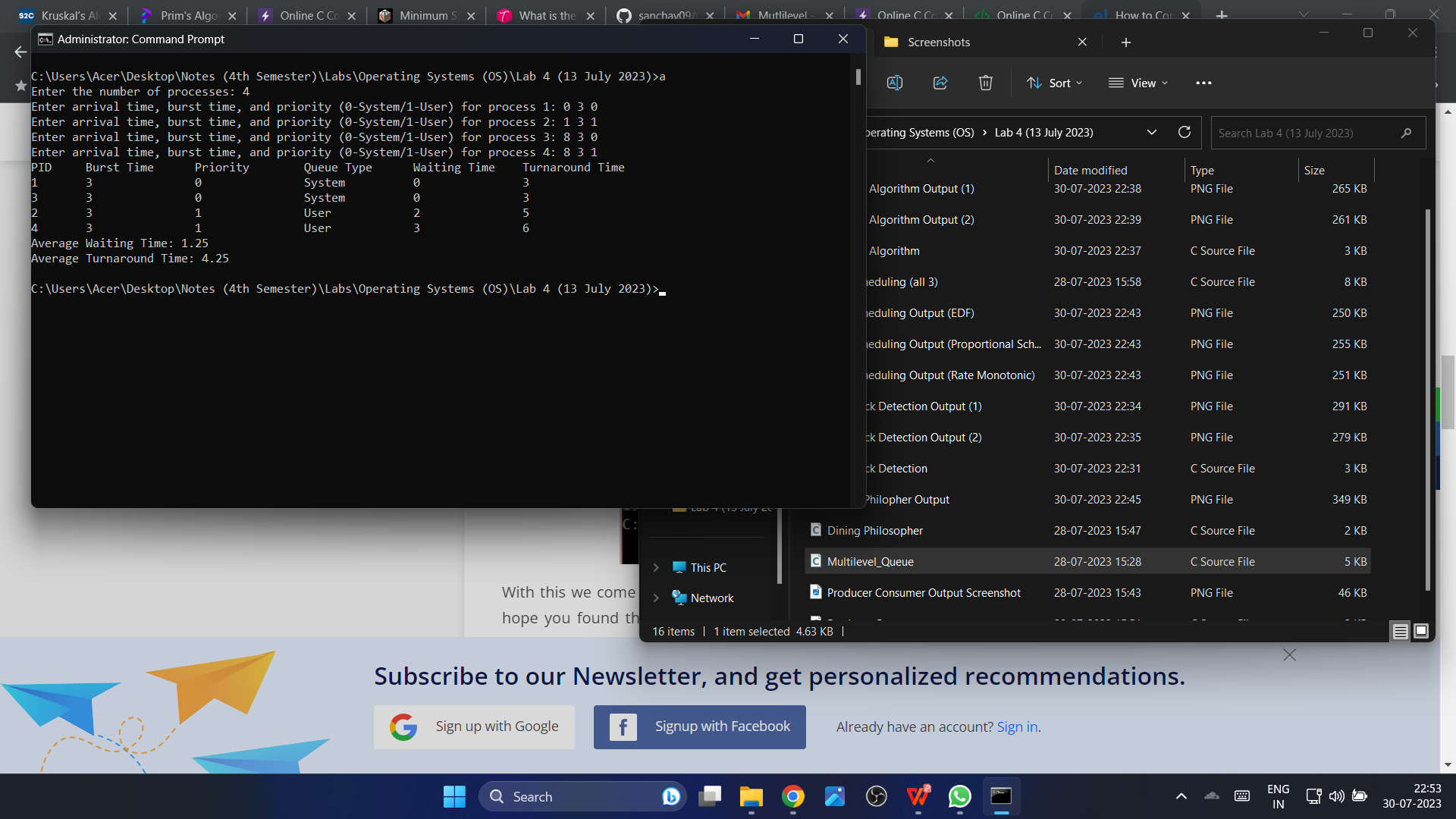

**Observation Book Pictures:**

